****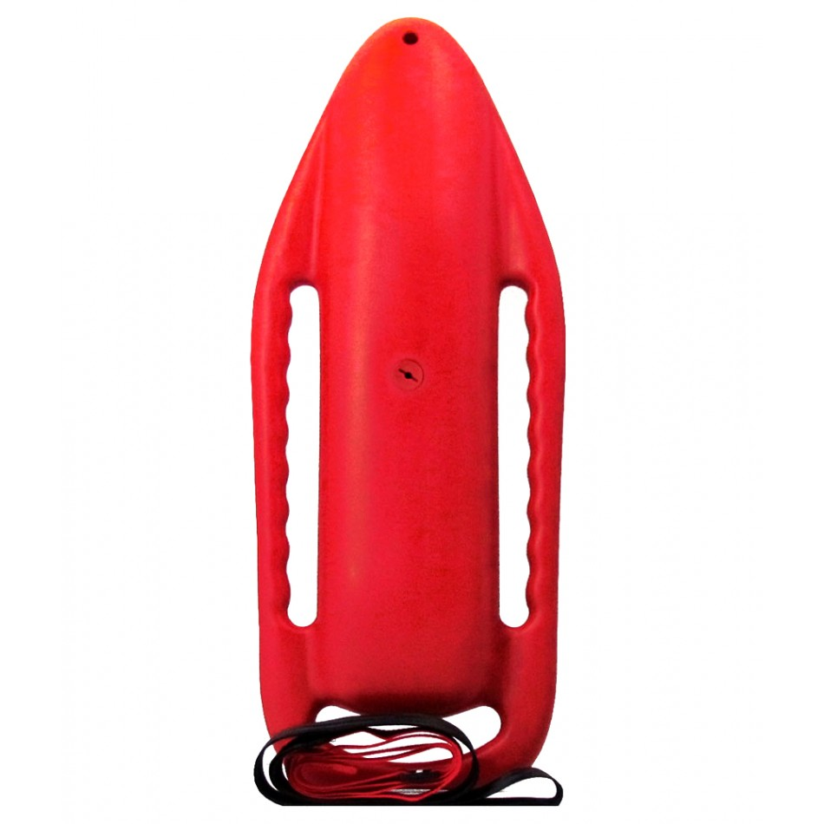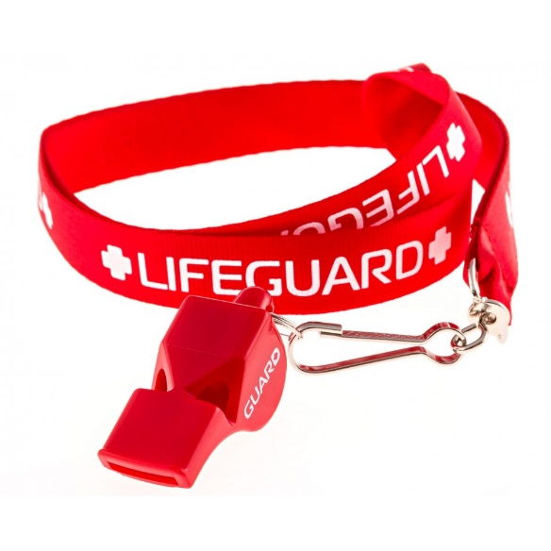

**Registration NOW OPEN Online:**

At Activenet:

<http://apm.activecommunities.com/oakridgerecandparks/Activity_Search/717>

Website: <http://orrecparks.oakridgetn.gov/>



Oak Ridge Civic Center Indoor Pool, 1403 Oak Ridge Turnpike

**Age:** At least 15 or older

**Dates:** **Winter Class** Dec. 27-30

**Spring Class** March 12-15

**Time:**  9am-2pm

**Fee:**  $135.00

$35.00 non-refundable Red Cross Fee

(to be paid on-line when registering for videos)

**LEARN HOW TO SAVE A LIFE!**

**Class includes Red Cross Lifeguard Certification, CPR/AED, First Aid, and O2 Certification**

Participants must attend all sessions and must be able to pass **pre-requisite** swim: 300 yard freestyle and breaststroke swim, tread water for 2 minutes using legs only, and swim to the depth of 10ft to retrieve a 10 pound object.

This is a blended learning class: must have access to internet and working email to watch required videos.

**Questions?** Call 865-425-3441

**LIFEGUARD**

**CERTIFICATION**