City of Oak Ridge Youth Advisory Board
August 20, 2014
Social Room, Oak Ridge Civic Center
2:00 p.m.

AGENDA

- Roll Call and Introductions

- Approval of Minutes
- 6.8.14

- Appearance of Citizens

- Report of Officers
- Finance Report

- Unfinished Business
- Goals Discussion for 2014-2015

- New Business
- None

- Announcements
- Next Meeting: Sept 3 @ 2pm

- Adjournment

YAB Calendar Summary

Regular Meetings for 2014-2015
- August 6 and 20
- Sept 3 and 17
- Oct 1 and 22
- Nov 5 and 26
- Dec 3
- Jan 7 and 21
- Feb 4 and 18
- Mar 4 and 25
- Apr 1 and 15
- May 6

Special Event Dates (Upon YAB Approval)
City Halloween Party – October 30 (Thu. PM)
Turkey Bowl Disc Golf Tourney – Nov 23 (Sun. PM)
Holiday Trip – TBD
Nashville Leadership Trip – February 18 or 25 (Wed)
Battle of the Bands – April 24 or May 1 (Fri. PM)
Graduation Celebration – May 28 (Thu. PM)

Other possible events/ideas
Water Awareness Classes Afterschool events (Girls Inc, etc)

Dodgeball Tournaments or leagues
Kickball Tournament?
Tennis Play Day
Ultimate Frisbee?
Trips/Day trips
National League of Cities
Summer Jobs & Career Fair
Youth forums, youth projects, or surveys
Community events, fundraisers, and efforts
Cash Mobs

Coffee House/Open Mic Events

2014-2015 YAB Goals and Objectives

- Sponsor recreational activities for students Event Chairs
- Battle of the Bands – April 24, 2015
- Graduation Celebration – May 28, 2015 YAB Seniors
- Holiday Event for Teens - TBD
- City Halloween Party – October 30, 2014
- Turkey Bowl Disc Golf Tournament– November 24, 2014
- Dodgeball Tournament for Teens – TBD
- Kickball Tournament – TBD

- Sponsor educational events or programs
- ORHS Open House – TBD
- YAB Scholarship
- Water Awareness for Kids – January 2015
- YAB Leadership Trip to Nashville with Youth Leadership

- Offer community volunteer services
- Support the Mission of Hope holiday program – Nov. 26, 2014
- Promote the Secret City Festival to teens
- City Easter Egg Hunt – March 28, 2015

- Increase communication within Oak Ridge Schools
- Communicate regularly with Student Affairs and Guidance
- Promote Graduation Celebration
- Partner on an event with ORHS Student Council – Bowl-a-Thon Event
- Make regular announcements via Channel 15, school bulletin

- Provide youthful insight on developments, programs, and public matters
- Student Traffic and Safety Issues
- Survey Oak Ridge Teens on retail, developments, & programs
- Promote Police & Fire Careers among Oak Ridge Teens (Jr. Police Academy)

- Increase public’s awareness of YAB programs
- City website updates
- Facebook/Instagram/Twitter for YAB Events – updated weekly
- News Releases to papers and school bulletins

- Increase communication and participation within the Board and with City Council
  - Focus on attendance at meetings and events
  - State of the Youth Address - Summer 2015
  - Conduct a Survey of Youth and report findings to City Council

Graduation Celebration Fact Sheet
WHAT IS GRADUATION CELEBRATION? GC is an all-night party for new high school graduates in Oak Ridge. The event is hosted by the Recreation and Parks Department in partnership with the City Youth Advisory Board and the Graduation Celebration Community Foundation. The event is held each year at the Oak Ridge Civic Center on ORHS graduation night from 10pm to 6am.
WHO FUNDS THIS PARTY? GC is funded primarily through community donations from businesses and individuals. The City also provides management, staff support, postage, and supplies for the event.
- Graduation Celebration is FREE for all new graduates of ORHS.
- Every graduate that attends wins something!
- The attendance at GC has been over 80% of the graduating class since 2006.
- Students must graduate on-time in order to attend Graduation Celebration.
- Students will enter the building between 10pm and 11pm on graduation night.
- Students can check-out early, but parents will be contacted for permission to leave, and the graduate will not be eligible for final drawings.
- Students must stay until the end of the party for a chance to win big prizes, cash and scholarships. These prizes range from laptops and tablet computers to cash and scholarships.
- Students must get parent/guardian permission to attend the party via a yellow permission form even if the student is 18 years of age or older.
- If a permission form is turned in, and the graduate doesn’t arrive at the party by 11pm, the parent/guardian will be contacted to verify the absence.
- Students that register early (by May 15th) are entered into a drawing for an extra prize. This is typically something like an IPAD, gaming system, or TV.
- Parents and community members that wish to volunteer must fill out a volunteer application each year. The deadline to volunteer is typically May 1st of each year.
- Graduation Celebration is a secure, drug-free, and alcohol-free event. Students must go through a security check upon entering the event.

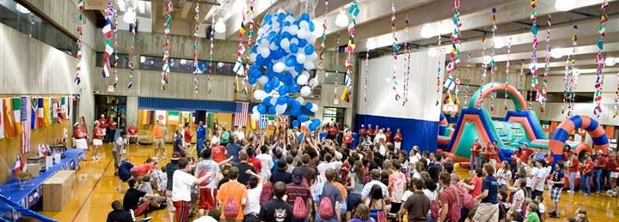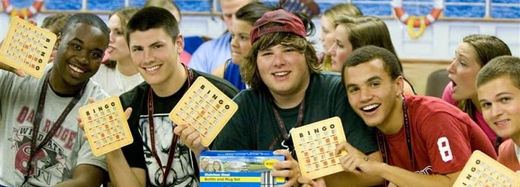
- To make a donation, visit www.orhsgradcel.org. Online donations accepted!
- To volunteer, send an email to tlong@oakridgetn.gov
For more information, contact Matt Reedy with the City of Oak Ridge Recreation and Parks Dept. at mreedy@oakridgetn.gov or by calling 425-3442.

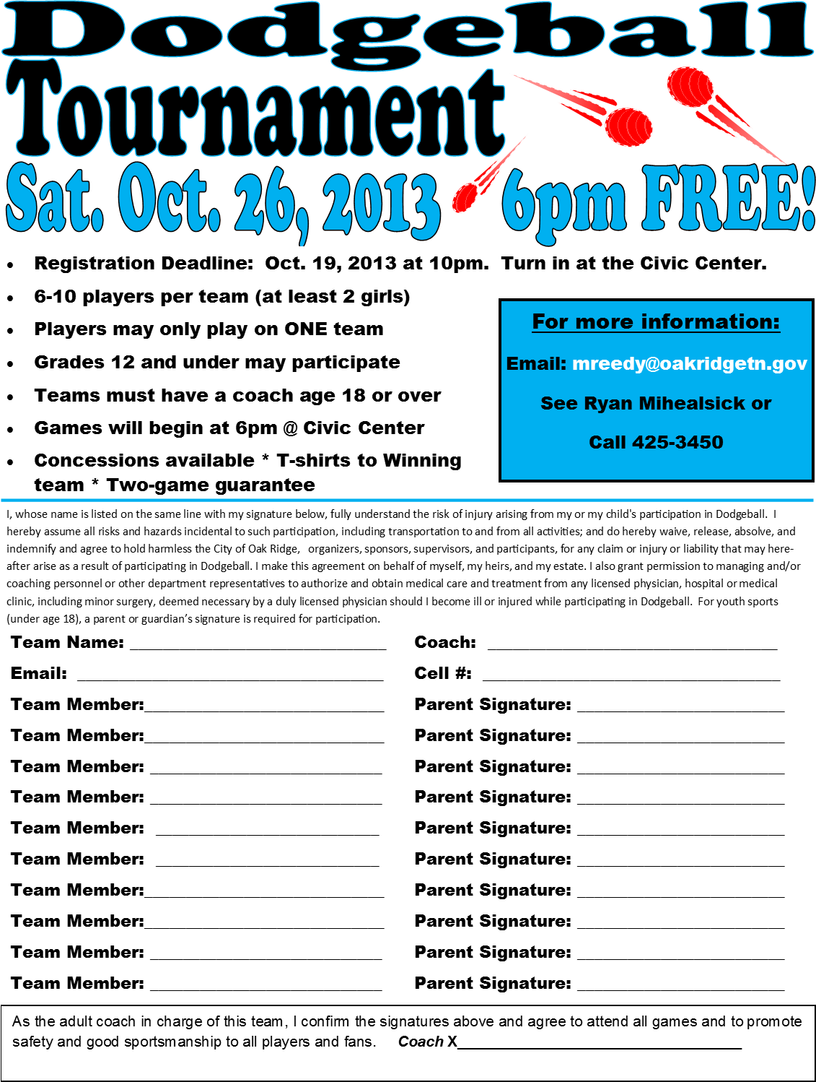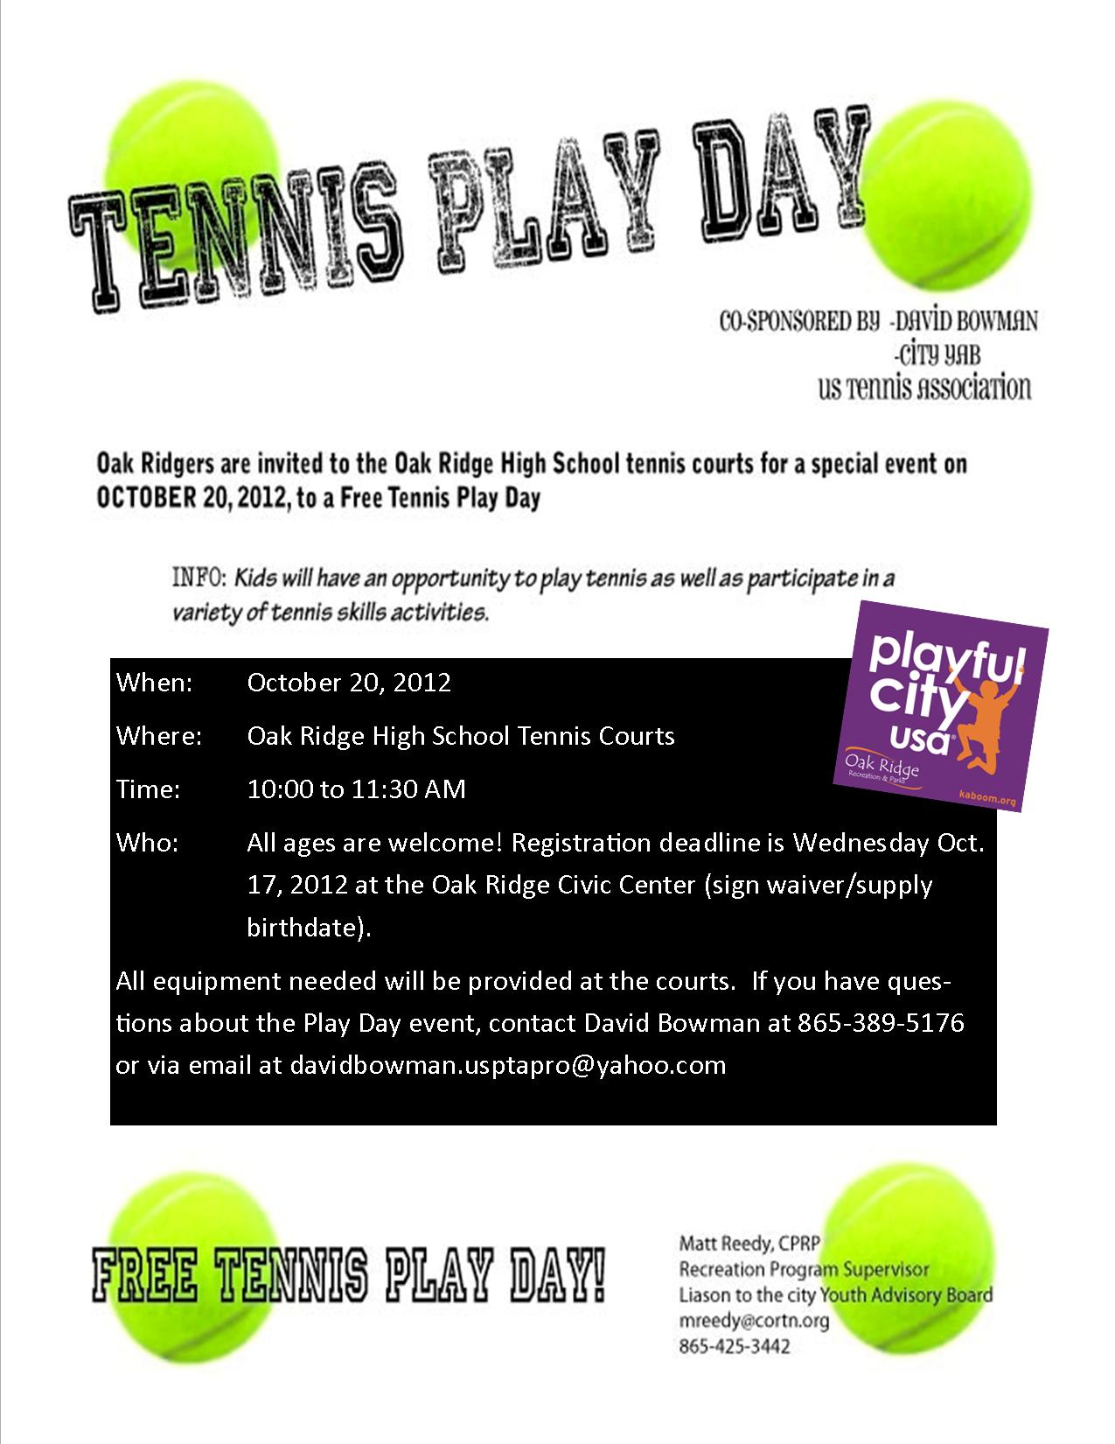

 Battle of the Teen Bands





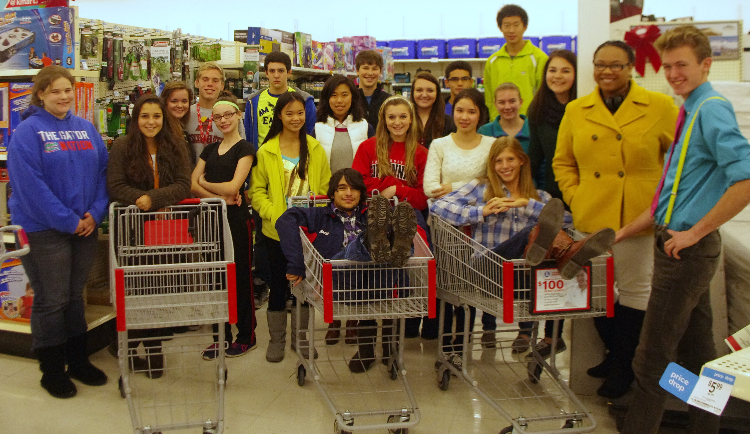
Mission of Hope Shopping – Over $1500 donated

Girls Inc Teen Room

 Nashville Leadership Trip

