Please review all forms in this application package and submit a completed application to:

Julie Lee
Fax: 865-425-3418
Email: jlee@oakridgetn.gov
Contact Number: (865) 425-3446

All persons making application must be at least 21 years of age and be on site for event.
*Note: Persons other than the contact listed will not be allowed to make event changes.

Approval of an event will be granted upon receipt and review of the application and acquisition of necessary permits, licenses, certificates, inspections, and payment of appropriate fees. It is the responsibility of the event sponsor or designee to obtain all necessary permits and pay all relevant charges and fees prior to the date of the event. Failure to comply will result in the event being cancelled. No make-up dates will be scheduled. Facilities will be returned to pre-event condition.

If facilities are unavailable due to a previously scheduled event, the Recreation and Parks Department will help with the selection of other times or dates. Note: Rain dates are prohibited.

Name of Event: _______________________________ Date(s) ___________________

Time(s) of Event: Start Time__________ End Time____________

Organization Name ________________________Organization Contact Name_______________________
Address: _________________________ City/State: _________________ Zip__________________
Contact Phone # W: ____________________H: __________________Cell____________________
E-mail address: ________________________________________________

GENERAL INFORMATION:

Profit/Non-Profit Status: _______________ Estimated Number of Attendees*: ________________
*(Large Events = projected attendance of 100 or more)

Event Location: _______________________________________________________________

Brief Description of Event (including individual event activities):

SITE INFORMATION

Please check YES or NO for each of the categories listed below. Failure to do this will slow the application process and require further explanation at a later date.

Alcohol/Beer Availability Yes_____ No_____

A facility user may serve alcoholic beverages only when they are a part of the normal refreshment for an event or meeting. They must be incidental to the purpose of the event and only one phase of the total refreshments being served. In all cases, the groups using City facilities must secure permits from the State and/or City in order to serve alcoholic beverages. If beer is planned, the City, through its Legal Department, will be able to advise the applicant. If wine or liquor is planned, the State Alcoholic Beverage Commission must be consulted. These permits must be secured and must be presented to the Recreation and Parks Department NO LATER THAN TWO WEEKS BEFORE THE EVENT. Any time alcoholic beverages are being consumed, the applicant must secure insurance that provides liquor liability in the amount of $1,000,000 with the City of Oak Ridge named as an additional insured party on the policy. A Certificate of Insurance must be presented to the Recreation and Parks Department at least 48 hours in advance of the event. When alcoholic beverages are being served/consumed at an event on City property, it is the responsibility of the user to furnish a commissioned security officer(s) at the sponsor’s cost.

SECURITY Yes_____ No______
Large events (projected attendance of 100 or more) will require security.
***One security officer is required for every 100 people***
Security officers must be bonded/licensed. License proof must be presented to the
Recreation and Parks Department one week prior to the event.

Insurance Certificate Yes______ No______

Name of Carrier________________________________________________________
This insurance information must be provided for any event being held on property owned or leased by the City of Oak Ridge. The City of Oak Ridge must be listed as an Additional Insured Party on the event liability policy (minimum amount $1,000,000.00). Certificate must be presented to the Recreation and Parks Department one week prior to the event.

Trash Removal Plan Yes______ No______
How will the trash generated by the event be handled? Will a dumpster be moved to the site? Trash boxes plus 1 liner each may be provided by the Recreation and Parks Department. (See Request Items List & fees, page 6)

Parking Plan Yes______ No______
Sponsors of large events will be required to submit a detailed parking plan that includes proposed parking locations, traffic control measures, and staffing.

Electrical Needs Plan Submitted Yes____ No____
Electrical Permit Yes____ No____
Describe the type of equipment to be used and the plan for electrical outlets. If special electrical connections are necessary, an electrical permit and inspection may be required.
Event Specific Fees will be charged. On-site meetings with Electrical Department are recommended. Electricity needs = Electric Department (See Contact List, page 9)

Banner Plan Yes_____ No______
On-Site Signs Yes_____ No_____
Will the applicant be posting or erecting temporary signs regarding the event at the site? If yes, 1) inform the Recreation and Parks Department at time of Reservation and 2) secure permits from the Community Development Department. (See Contact List, page 9)

Special Event (Vendor) Business License Yes_______ No______
Contact the City of Oak Ridge Business Office. (See Contact List, page 9)

CATERER Yes____ No_____
Person/group hosting event will be responsible for caterer.
Caterer should be informed of policies and rental times prior to the event.
Name of Caterer ____________________________________________
Contact Person _____________________________________________

Person/group hosting event will be responsible for informing Caterer of set-up and
break-down times, trash removal and use of equipment. Trash must be removed from site.
Equipment used must be returned to pre-event condition this includes.
Additional time may result in Overtime Charges.

Police Support and Services Yes______ No_____ (See Request Items List & fees, page 6)
Contact the Oak Ridge Police Department for police support and services. (See Contact List, page 9)

Public Works Department Support and Services Yes____ No____ (See Contact List, page 9)

Fire Department Support Services Yes______ No_____
Contact the Oak Ridge Fire Department for support and services. (See Contact List, page 9)

Will Onsite Medical Personnel Be Required? Yes______ No_____

If yes, please furnish name _________________________________

Please check all that apply

Street Barricades
If barricades are needed to close streets, inform the Recreation and Parks Department. (Types of barricades available are barrels, channelizers and cones.) Event Specific fees will be collected. (See Request Items List & fees, page 6).

Street Closure
If any part of a Public Street or thoroughfare will be closed, written permission from the Oak Ridge Police Department & City Manager must be obtained. A traffic control plan will be required. (See Contact List, page 9)

Noise Ordinance Waiver Request

The applicant will be required to submit in writing a request for a waiver of the City’s noise ordinance if sound will be clearly audible on a property or in a dwelling unit other than that in which it is located. The request should include time, date, place, and nature of the request. Contact City Manager’s office. (See Contact List, page 9)

EVENT SITE LAYOUT

ALL TENTS MUST BE FREE STANDING. NO STAKES ALLOWED

*Indicate on map location and size of tents.
*Who is responsible for setting up/taking down tents? ___________________________
*When will tents be set up/removed? __________________________

Event Site Layout & Locations List

***Mark the attached site plan map (see page 10 or 11) indicating the location of the following:***

● Activity areas/tents/kiosks/structures
- Food/cooking/hand washing facilities
- Area where alcohol will be served
- Music/bandstand area/speakers/sound booth
- Restrooms/portable toilets
- Street Barriers/traffic control plan will be required
- Parking areas/shuttle bus stops
- Sign Plan showing publicity, directional and day-of-event signs
- First Aid Station

City Support and Services Needed? Yes___ No___
(If Yes, please fill out Request Items List, page 6)
CITY SERVICES REQUESTED/REQUIRED
SERVICES MUST BE ARRANGED AT LEAST TWO WEEKS PRIOR TO EVENT!
The services below are available from, or may be required by, the City of Oak Ridge. If additional support services are requested by the sponsor or required by the City, the applicant will be informed at the review session of appropriate contacts, fees and conditions for all required additional services. The applicant should provide written confirmation of reservations/arrangements with the appropriate department(s) two weeks before the event.

NOTE: Facility user will be responsible for transporting items to event site. Some items may be included in facility rental. Fees and deposits may apply. Check with Recreation and Parks upon requests.

City Services Request Items List

*Items are reserved based on availability and at the discretion of the City of Oak Ridge*

Item | Department | Cost | Deposit | Quantity
Barrels & Channelizers | Rec & Parks | $5.00 each
Cones | Rec & Parks | $1.00 each
Security Vests | Rec & Parks | $1.00 each
Electrician Services | Electric | $50.00 / hour
Electric Spider Boxes | Electric | $20.00 each
ORPD Officers | Police | $45.00 per officer per hour
Other Needs
Other Needs
Other Needs

HOLD HARMLESS AGREEMENT

The applicant covenants to save, defend, hold harmless and indemnify the City, and all of its officers, departments, agencies, agents and employees (Collectively the “City”) from and against any and all claims, losses, damages, injuries, fines, penalties, costs (including court costs and attorney’s fees), charges, liability, or exposure, however caused, resulting from, arising out of, or in any way connected with the applicant’s event as herein described.

The Special Event described above is approved subject to any conditions noted on this form or otherwise set forth by the City of Oak Ridge.

I agree to abide by all City rules and policies established by the City for use of City Property.

Signed_____________________________________________________________

Print Name__________________________________________________________

Position_____________________________________________________________

Date_______________________________________________________________

EVENT APPLICATION APPROVAL

Recreation and Parks Department Date
Contact Person

Recreation and Parks Department Date
Director

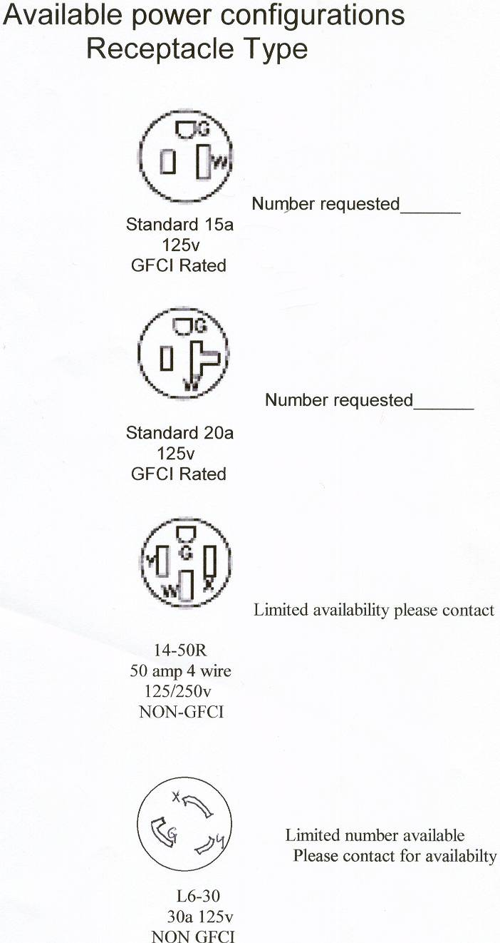

Contact List:

Recreation and Parks 865-425-3446
Recreation and Parks Fax 865-425-3418
City Legal Department (Beer License) 865-425-3556
State Alcoholic Beverage Commission 865-594-6342
Oak Ridge Police Department 865-425-3504
Oak Ridge City Manager 865-425-3550
Code Enforcement Division 865-425-3532
Community Development 865-425-3531
City of Oak Ridge Business Office 865-425-3400
Public Works 865-425-1875
Fire Department 865-425-3521

Notes

________________________________________________________________________________
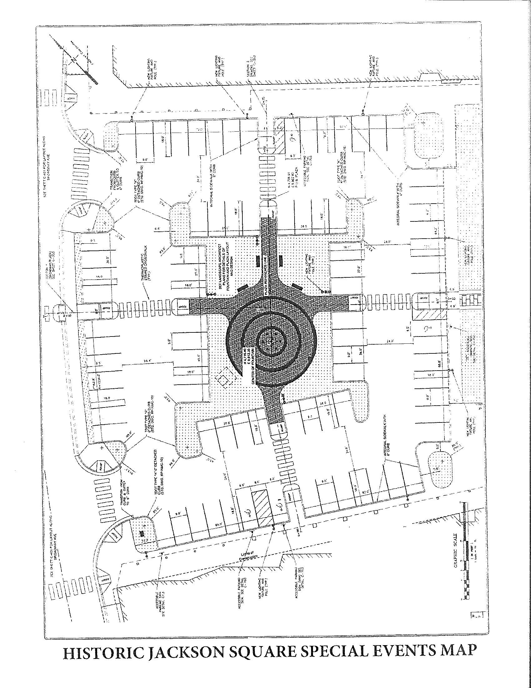
***Mark up with required Event Site Layout & Locations*** (See page 5)

MELTON LAKE PAVILION & MARINA AREA

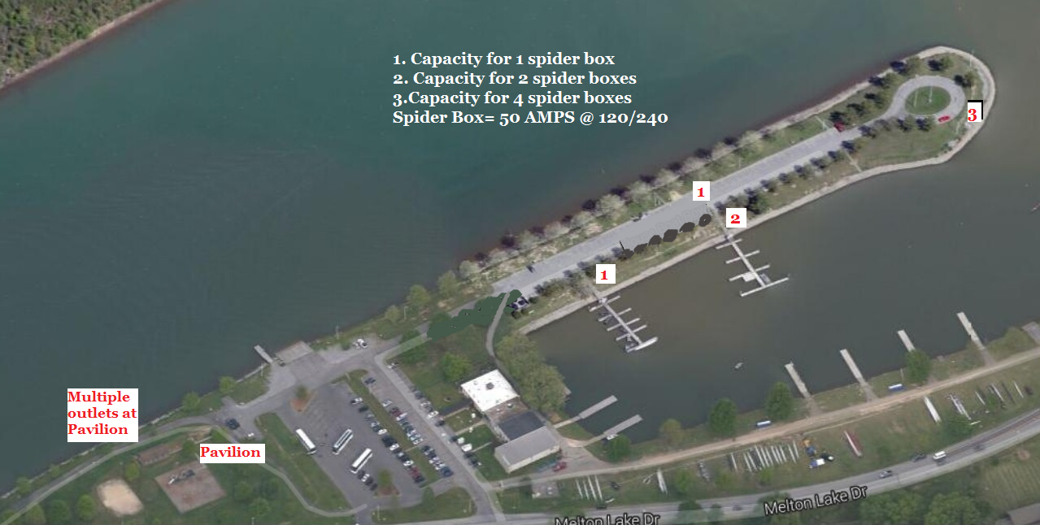

***Mark up with required Event Site Layout & Locations*** (See page 5)

