Oak Ridge Civic Center
Fairy Self Portrait Class
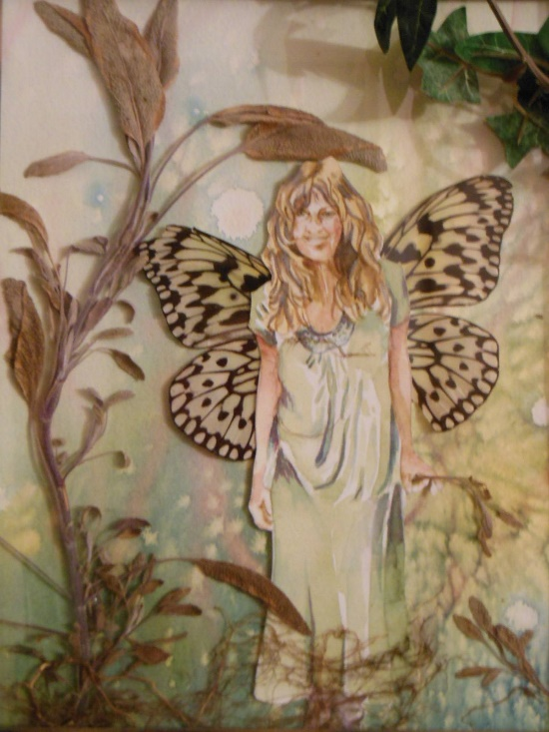
July 8th, 12th, 11th , 15th, 17th, and 18th
4:00-5:00
Every wondered what you would look like as a fairy? Find out in six, one-hour sessions this summer by making a collage of yourself with pressed flowers, leaves, and other objects from nature, along with watercolor and drawing, to create a scene where you are the fairy. These images can be framed and/or saved digitally so you can print them on greeting cards, post cards, magnets and more!
$70 all supplies included.
For ages 10-14
Call 425-3450 or visit www.orrecparks.org to find out more.
