City of Oak Ridge Youth Advisory Board
August 4, 2021
Social Room, Oak Ridge Civic Center
2:05 p.m.

AGENDA

- Roll Call and Introductions

- Swearing-in of the City YAB for 2021-2022
- City Clerk’s Office

- Elections of Officers
- Chairperson, Vice Chairperson, Secretary, and Treasurer

- Approval of Minutes
- 4.28.21

- Appearance of Citizens

- Report of Officers
- Finance Report

- Unfinished Business
- None

- New Business
- YAB Orientation
- Policies, procedures, and Bylaws review

- Goals Discussion for 2021-2022

- Announcements
- Next Meeting: August 18 @ 2pm

- Adjournment

YAB Officer Positions

Chairperson: The Chairperson shall preside at meetings of the Board, prepare the agenda for the meetings and make a copy available to the Secretary; call special meetings; call special elections; sign, together with the Secretary or any other designated officer of the Board, any documents or instruments authorized to be executed by the Board, except in those cases where such execution has been expressly delegated by the Board or by these Bylaws to another officer of is required by law to be otherwise handled; and in general shall perform all duties as may be prescribed by the Board from time to time, in accordance with all applicable State and City laws and procedures.

Vice-Chairperson: The Vice-Chairperson shall preside at meetings in the absence of or at the request of the Chairperson and shall become Chairperson for the remainder of the term in the event of the resignation, death, or removal of the Chairperson. In the temporary absence or disability of the Chairperson, the Vice-Chairperson shall assume the duties of the Chair and in that event shall have all the powers of and be subject to all the restrictions of that office. The Vice-Chairperson shall perform such other duties as may be assigned from time to time.

Secretary: The Secretary shall be responsible for the preparation of minutes of the meetings of the Board and upon their approval, shall provide a signed copy to the City Clerk for filing and distribution to City Council. The Secretary shall keep a copy of the Board's minutes in a record book which shall be passed on to his or her successor; shall have custody of all important records of the Board, excluding financial records; shall sign with the Chairperson or Vice-Chairperson any documents or instruments which the Board has so authorized to be executed; shall assure that all notices are duly given as required by law, these bylaws, or the Board; shall call the meetings of the Board to order in absence of the Chairperson or Vice-Chairperson and shall conduct an election for a temporary presiding officer for that meeting; and shall perform all duties incident to the office of Secretary and such other duties as from time to time may be assigned by the Board. In the absence of the Secretary, the Chairperson will appoint another member to be responsible for the preparation of the minutes of the meeting.

Treasurer: The Treasurer shall be responsible for reviewing records of all financial transactions of the Board; shall process, collect, and remit all fees and charges and deposit all funds with the City of Oak Ridge; shall report on the financial condition of the Board; and shall perform such other duties as from time to time may be assigned by the Board. The Treasurer will serve as the Concessions Chairperson in most cases.

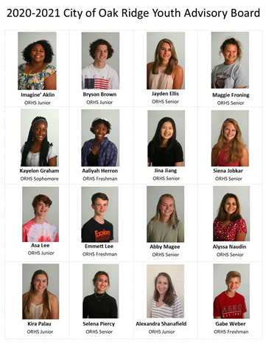
YAB Calendar Summary

Regular Meetings for 2021-2022
- August 4 & 18
- Sept 1 and 15
- Oct 13 and 27
- Nov 3 and 17
- Dec 1
- Jan 5 and 19
- Feb 2 and 16
- Mar 2 and 30
- Apr 6 and 20
- May 4 and 18

Special Events/Discussion Points (Upon YAB Approval)

City Halloween Party – Oct. 28 (Thu. 6PM – 8:30PM)
Youth Jobs Fair - TBD
Nashville Leadership Trip – TBD
Graduation Celebration – May 20th or 27th (Fri. 10PM – 5AM)
Fall/Spring Dodgeball Tourney – TBD
Breakfast with Santa – Dec. 4th (8am-10am)
ASAP Movie Nights – Fall/Spring
Teen Room at the Library/Civic Center
Oak Ridge Municipal Swimming Pool
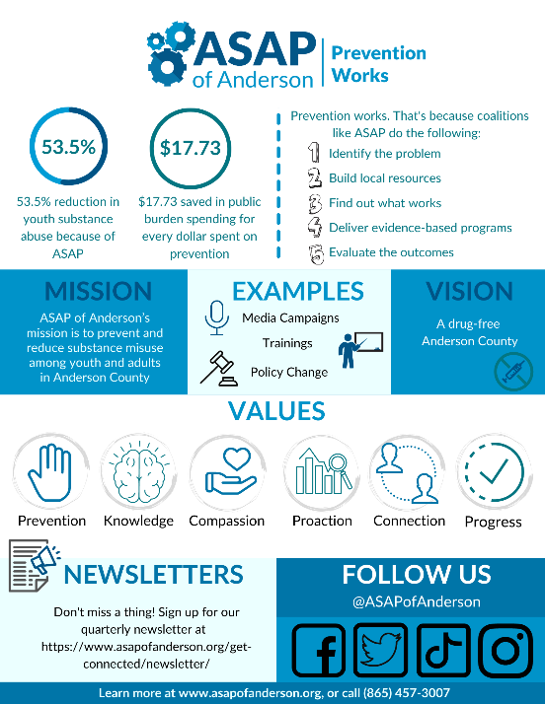

GOALS FROM LAST YEAR
2020-2021 YAB Goals and Objectives

Sponsor recreational activities for students
- Graduation Celebration – May 27, 2021
- Investigate the need for teen space at the Oak Ridge Public Library/Civic Center
- Zoom with Santa – December 4-6 2020
- City Halloween Drive-Thru Event – October 29, 2020
- YAB Field Night/Color War/Dodgeball Event – May 2021
- Drive-in Trivia Night – Dec. 19th
- Winter Formal at ORHS – TBD

Sponsor educational events or programs
- Offer a Virtual Jobs Fair for Teens – Fall 2020
- Water Awareness for Kids – May 2020
- YAB Leadership Trip to Nashville – February 2020
- Co-Sponsor an event for special needs students with ORHS Interact Club – TBD
- Sponsor an Art in the Park/Virtual Art Auction event

Offer community volunteer services
- Provide holiday support to families in need (Toy Drive/Holiday Giveback)
- Support the City Easter Eggspo Event

Increase communication within Oak Ridge Schools
- Communicate regularly with Student Affairs and Guidance
- Promote Graduation Celebration
- Partner with ORHS Student Council, ORHS Senior Steering, ASAP, Wildcat Mentoring, and Key Club
- Make regular announcements via Channel 15, school bulletin
- Offer a Survey of Students – Sept 2020

Increase public’s awareness of YAB programs
- City website updates
- Facebook/Instagram/Twitter/Group Me for YAB Events – updated weekly
- News Releases to local news, school bulletins, Canvas, and ORHS Twitter pages

Increase communication and participation within the Board and with City Council
- Focus on attendance at meetings and events
- State of the Youth Address - Summer 2021
- Implement YAB Icebreaker Events to increase board communication
- Seek funding for needed upgrades for the City Skate Park

City of Oak Ridge, Tennessee

BYLAWS

of the

YOUTH ADVISORY BOARD

Article I. Name

The name of the organization shall be the Youth Advisory Board (YAB) of Oak Ridge, hereinafter referred to as the Board. The YAB was originally established by City Council Resolution No. 12-159-91 on, and was recreated by Resolution No. 6-54-08 to better clarify the YAB’s purpose, function, and procedure for selection of its members.

Article II. Function

The function of the Board shall be to serve as a liaison between City Council and the youth of the Oak Ridge community on issues affecting youth, and to encourage the positive growth and development of youth by involving them in healthy social, cultural, recreational, and other activities. In the performance of its function, the Board is authorized to:

- Make recommendations to City Council and the City Manager on matters affecting the youth of the community.
- Plan, organize, coordinate, and carry out drug- and alcohol-free activities for the youth of the Community.
- Enter into agreements with entertainers, concessionaires, and other third parties as may be deemed desirable by the Board within available funds and in accordance with applicable State and City laws and procedures.

Article III. Participation

All community and area youth are eligible to participate in activities arranged or organized by the Board, subject to the rules and regulations established by the Board for such activities.

Article IV. Membership, Elections, and Officers

The Youth Advisory Board shall be comprised of sixteen (16) members, all of whom shall be students in the eighth through twelfth grade levels and residents of the City of Oak Ridge. The members of the Youth Advisory Board (YAB) shall be appointed by the Oak Ridge City Council upon recommendation by a YAB Screening Panel which shall be composed of one member of City Council, one member of the faculty of the Oak Ridge Schools, and the City staff member assigned to work with the Board. Contingent upon the availability of applicants, the Screening Panel shall strive to recommend at least two (2) students each from the 8th, 9th, 10th, 11th, and 12th grade levels.

All members shall serve a one-year term of office commencing August 1 and ending July 31 of the following year. Whenever a vacancy occurs prior to the expiration of a term of office, the Screening Panel shall recommend a replacement for consideration of appointment by City Council to serve the remainder of the term.

No later than September 1 of each year, the Board shall elect from its members a Chair, Vice-Chair, Secretary, and Treasurer whose terms shall end on July 31 of the following year. The duties of the Officers shall be as follows:

Chairperson: The Chairperson shall preside at meetings of the Board, prepare the agenda for the meetings and make a copy available to the Secretary; call special meetings; call special elections; sign, together with the Secretary or other designated officer of the Board, any documents or instruments authorized to be executed by the Board, except in those cases where such execution has been expressly delegated by the Board or by these bylaws to another officer or is required by law to be otherwise handled; and in general shall perform all duties as may be prescribed by the Board from time to time, in accordance with all applicable State and City laws and procedures.

Vice-Chairperson: The Vice-Chairperson shall preside at meetings in the absence of or at the request of the Chairperson and shall become Chairperson for the remainder of the term in the event of the resignation, death, or removal of the Chairperson. In the temporary absence or disability of the Chairperson, the Vice-Chairperson shall assume the duties of the Chair and in that event shall have all the powers of and be subject to all the restrictions of that office. The Vice-Chairperson shall perform such other duties as may be assigned from time to time.

Secretary: The Secretary shall be responsible for the preparation of minutes of the meetings of the Board and upon their approval, shall provide a signed copy to the City Clerk for filing and distribution to City Council. The Secretary shall keep a copy of the Board's minutes in a record book which shall be passed on to his or her successor; shall have custody of all important records of the Board, excluding financial records; shall sign with the Chairperson or Vice-Chairperson any documents or instruments which the Board has so authorized to be executed; shall assure that all notices are duly given as required by law, these bylaws, or the Board; shall call the meetings of the Board to order in the absence of the Chairperson or Vice-Chairperson and shall conduct an election for a temporary presiding officer for that meeting; and shall perform all duties incident to the office of Secretary and such other duties as from time to time may be assigned by the Board. In the absence of the Secretary, the Chairperson shall appoint another member to be responsible for the preparation of the minutes of the meeting.

Treasurer: The Treasurer shall be responsible for reviewing the records of all financial transactions of the Board; shall process, collect, and remit all fees and charges and deposit all funds with the City of Oak Ridge; shall report on the financial condition of the Board; and shall perform such other duties as from time to time may be assigned by the Board.

4. Chairpersons of specialized areas (events, publicity, concessions, etc.) may be appointed by the Chairperson with the consent of the Board.

Article V. Meetings

1. The Board shall conduct public, general purpose meetings at least twice each month except for the months of June, July and December. In December, meetings will be held once a month. Regular meetings shall commence at such time and dates designated by the Board and will be held at the Oak Ridge Civic Center or at such other location as may be designated by the Board. Special meetings shall be called as necessary to carry out the functions of the Board. The Board shall give proper notice of all meetings in accordance with the laws of the State of Tennessee. All meetings of the Board shall be open to the public and all regular and special meeting notices shall be provided to the local newspaper and the Oak Ridge City Council, as well as announced during school announcements at Oak Ridge High School, Jefferson Middle School, and Robertsville Middle School.

2. Any business may be brought by the Board at a regular meeting, whether or not that business is set forth in the agenda.

3. Special meetings may be called by the Chairperson or upon request of at least three (3) members of the Board.

4. Written notice of a special meeting shall be given to all Board members, the local newspaper, and schools at least 24 hours prior to the meeting, stating the business to be considered. Any member may waive notice of a special meeting. The attendance of a member at a special meeting shall constitute waiver of notice, except where such member attends the meeting for the express purpose of objecting to the transaction of business because the meeting was not lawfully called or convened.

5. To the extent possible, the following order of business shall be observed at regular meetings of the Board:

a. Roll call
b. Reading and approval of the minutes of the preceding meeting
c. Reports of officers
d. Reports of committees
e. Unfinished business
f. New business
g. Adjournment

6. At least a majority of the members then in office shall be a quorum for the transaction of business at all Board meetings, and the affirmative vote of at least a majority of the members then in office shall be required to take any action.

7. The Youth Advisory Board will follow the Oak Ridge School System schedule. For example, if school is canceled due to weather conditions and the Board was scheduled to meet that same day, their meeting will also be canceled and rescheduled at a later date. If a regular meeting of the Board is scheduled on a given school holiday, it will also be rescheduled to a later date.

8. Absences shall be treated in accordance with the established City Council attendance policy for boards and commissions.

Article VI. Reports to Council

By September 30 of each year, the Board shall submit to City Council an annual plan of work for its ensuing term. The Board shall also submit a written report of its activities at the conclusion of its term, preferably by July 1.

Article VII. Amendments to the Bylaws

1. Subject to the approval of the Oak Ridge City Council, these bylaws may be amended or repealed in whole or in part at any meeting of the Board, provided that written notice of the proposed amendment or repeal is given in the notice of such meeting and at least one week in advance of the meeting.

2. If an occasion arises that a question is not specifically covered by these bylaws, the latest edition of Robert's Rules of Order will apply.

Approved this 26th day of March 2014.

Graduation Celebration Fact Sheet
WHAT IS GRADUATION CELEBRATION? GC is an all-night party for new high school graduates in Oak Ridge. The event is hosted by the Recreation and Parks Department in partnership with the City Youth Advisory Board and the Graduation Celebration Community Foundation. The event is held each year at the Oak Ridge Civic Center on ORHS graduation night from 10pm to 6am.
WHO FUNDS THIS PARTY? GC is funded primarily through community donations from businesses and individuals. The City also provides management, staff support, postage, and supplies for the event.
- Graduation Celebration is FREE for all new graduates of ORHS.
- Every graduate that attends wins something!
- The attendance at GC has been over 80% of the graduating class since 2006.
- Students must graduate on-time in order to attend Graduation Celebration.
- Students will enter the building between 10pm and 11pm on graduation night.
- Students can check-out early, but parents will be contacted for permission to leave, and the graduate will not be eligible for final drawings.
- Students must stay until the end of the party for a chance to win big prizes, cash and scholarships. These prizes range from laptops and tablet computers to cash and scholarships.
- Students must get parent/guardian permission to attend the party via a yellow permission form even if the student is 18 years of age or older.
- If a permission form is turned in, and the graduate doesn’t arrive at the party by 11pm, the parent/guardian will be contacted to verify the absence.
- Students that register early (by May 15th) are entered into a drawing for an extra prize. This is typically something like an IPAD, gaming system, or TV.
- Parents and community members that wish to volunteer must fill out a volunteer application each year. The deadline to volunteer is typically May 1st of each year.
- Graduation Celebration is a secure, drug-free, and alcohol-free event. Students must go through a security check upon entering the event.

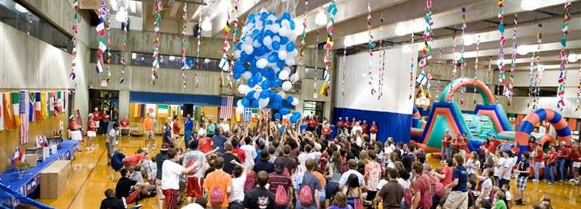
- To make a donation, visit www.orhsgradcel.org. Online donations accepted!
- To volunteer, send an email to tlong@oakridgetn.gov
For more information, contact Matt Reedy with the City of Oak Ridge Recreation and Parks Dept. at mreedy@oakridgetn.gov or by calling 425-3442.

